***SIT305 Assessment Project 2 Grading Criteria***

*Lawrence& Dante*

**Commits (bitbucket / GitHub)**

*(Pass/ Credit/ Distinction/HD)*

*GITHUB Link: https://github.com/Dollars1912/SIT305_Project2/commits/master*

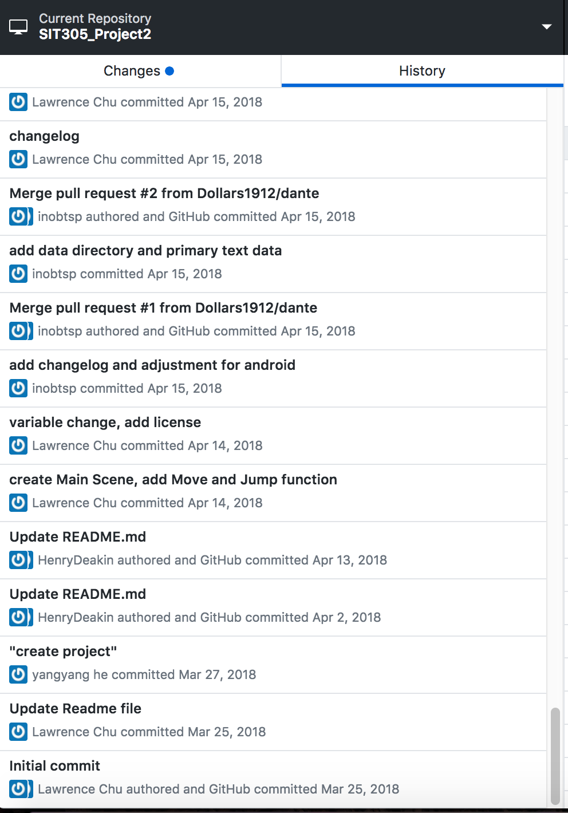 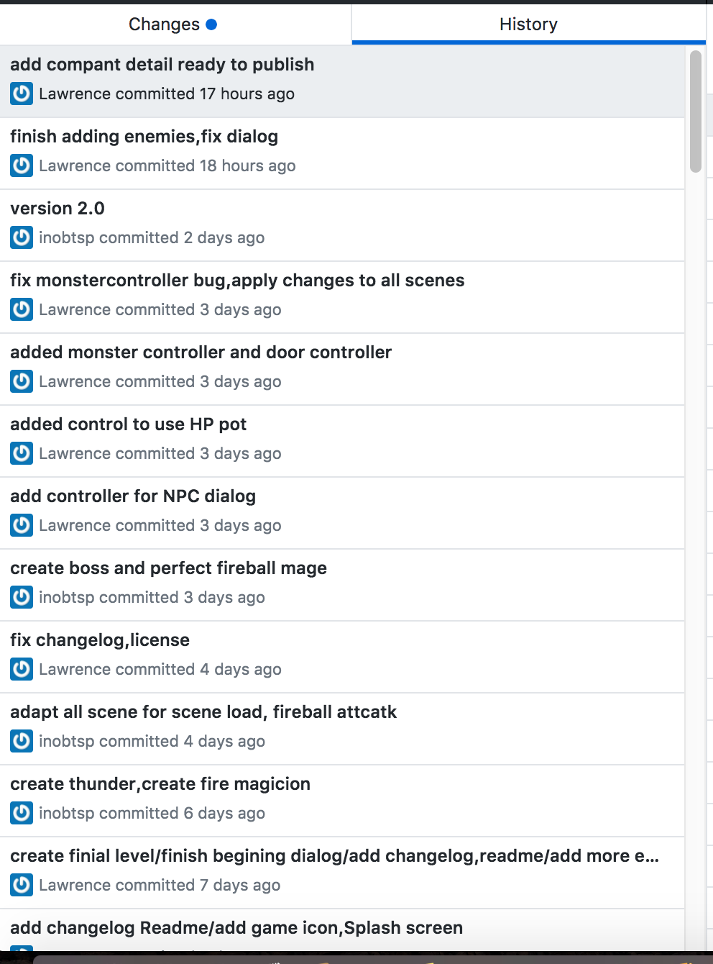

*We have a full commit record, and there is new progress almost every day. It's much more than 25 unique days’ commit. The teacher will leave Suggestions on our GitHub, and we did improve as quickly as possible.*

**Weekly progress**

*(Pass/ Credit/ Distinction/ HD)*

*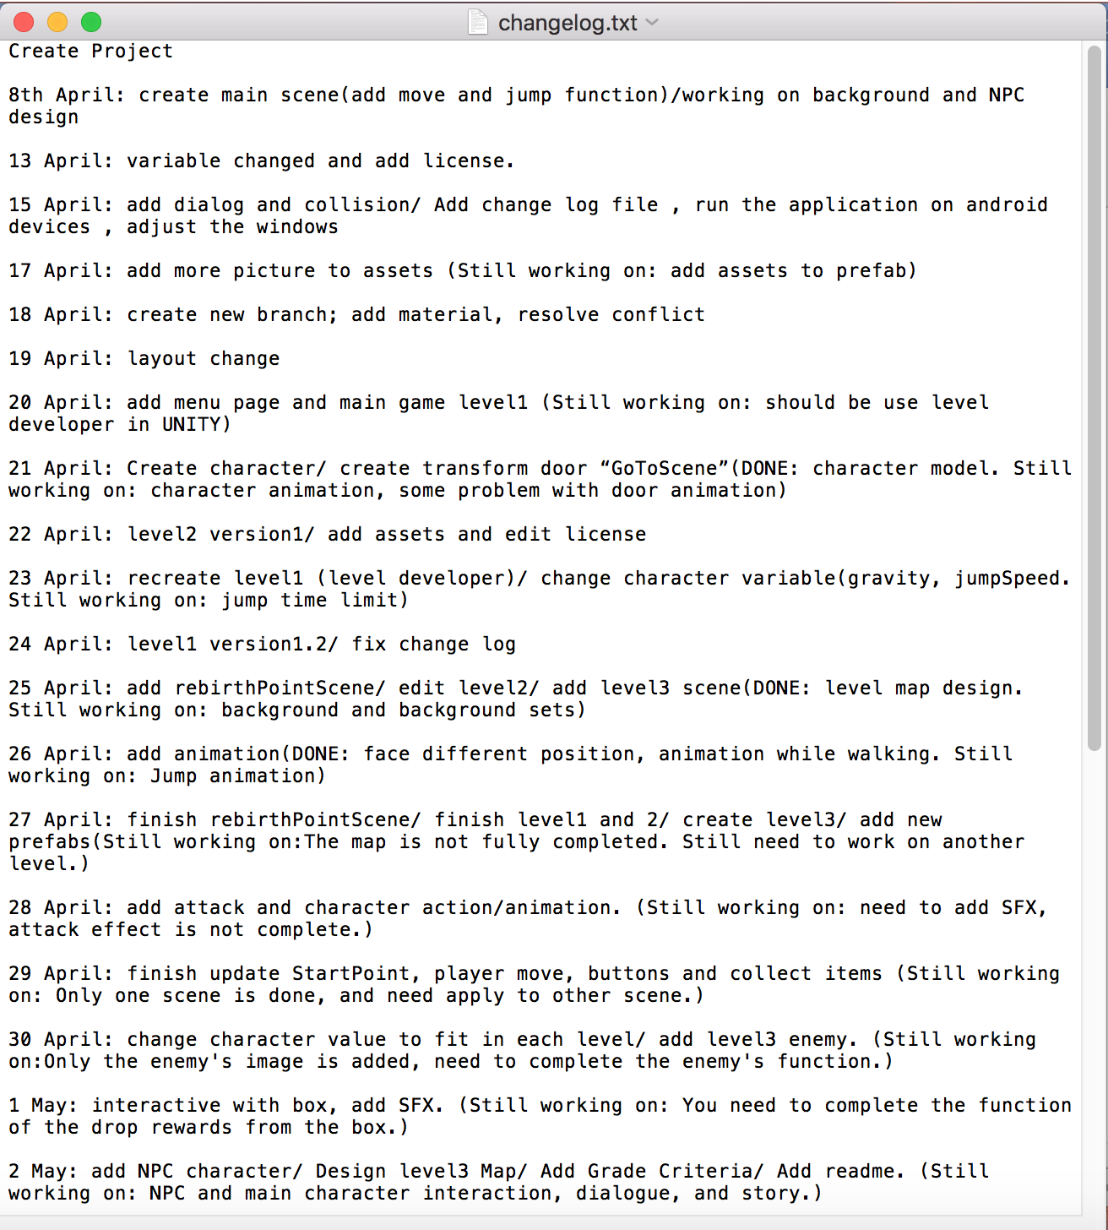we did update the changelog at least once a week. Also include “still working on” and the work summary as well.*

**Code quality**

*(Pass/ Credit/ Distinction/ HD)*

**Legal**

*(Pass/ Credit/ Distinction/ HD)*

*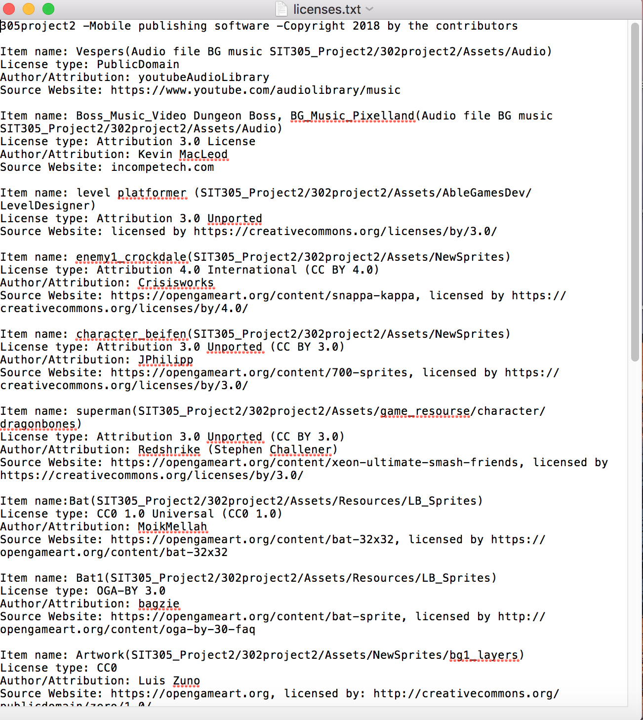licenses.txt is under the sit305Project file. Licenses include:*

* *Item name (image/sound file we have rename it to)*
* *License type (public domain/CC-BY/CC0/GPL…)*
* *Author/ Attribution (name of author, also include hyperlinks to the source pages, as per author wishes.)*
* *Sources website*

**Playability**

*(Pass/ Credit/ Distinction/ HD)*

*There is a difference in the amount of time each person plays the game. Our game is very challenging, there are different collection elements, training system, rich dialog and stories. So, it's not possible to go through customs very quickly.* *Through our test, the game time is between 6 and 10 hours.*

**Data Handling**

*(Pass/ Credit/ Distinction/ HD)*

**Layout**

*(Pass/ Credit/ Distinction/ HD)*

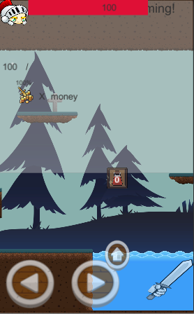 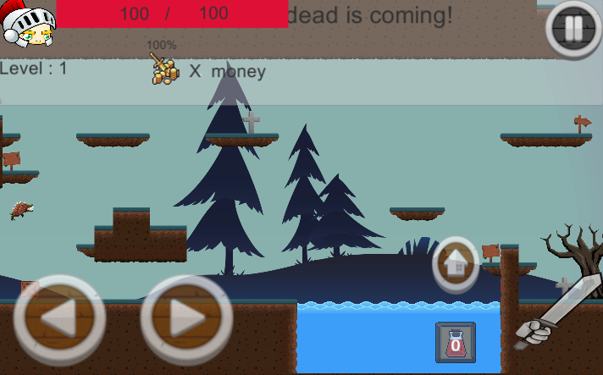

*We used canvas for making games. So, our app dynamically adjusts the in real - time to changes in orientation & resolution.*

**Bugs**

*(Pass/ Credit/ Distinction/ HD)*

**Readme.txt / .md**

*(Pass/ Credit/ Distinction/ HD)*

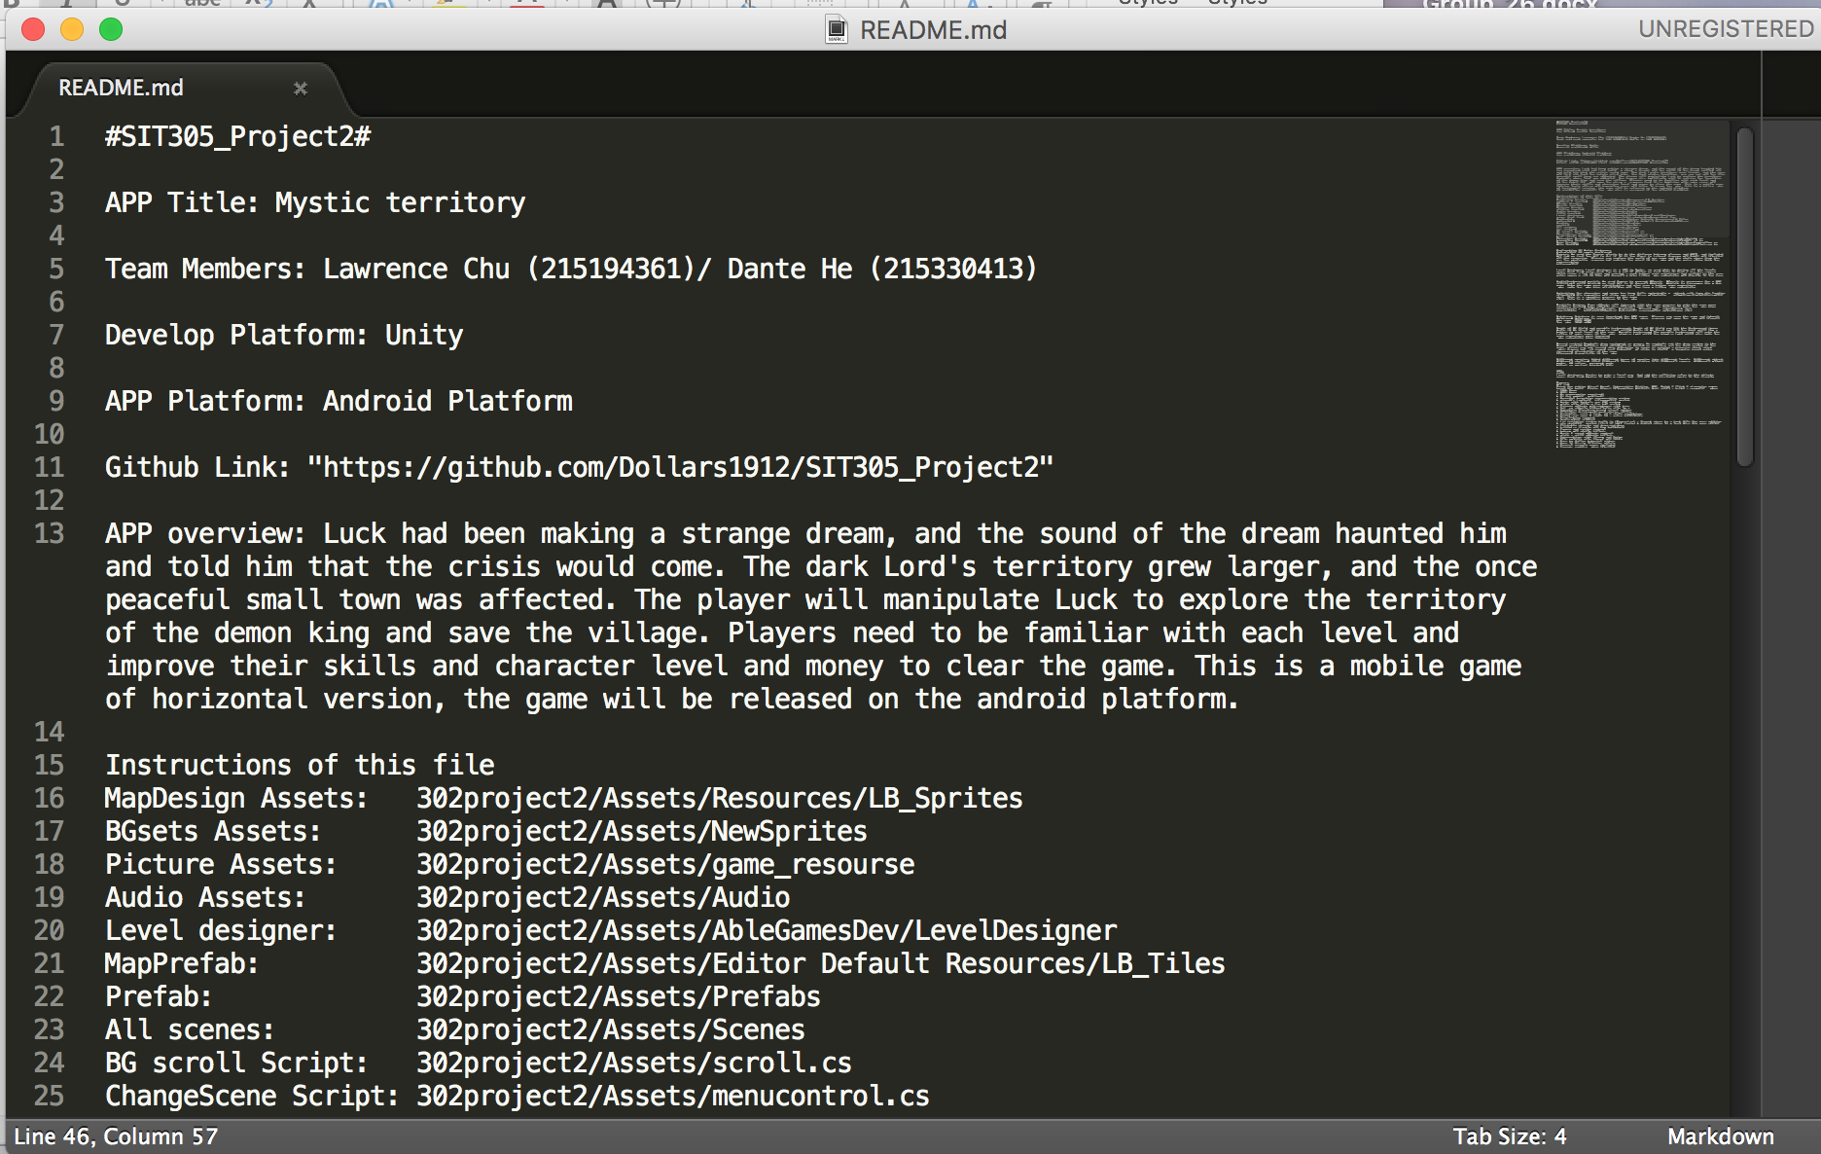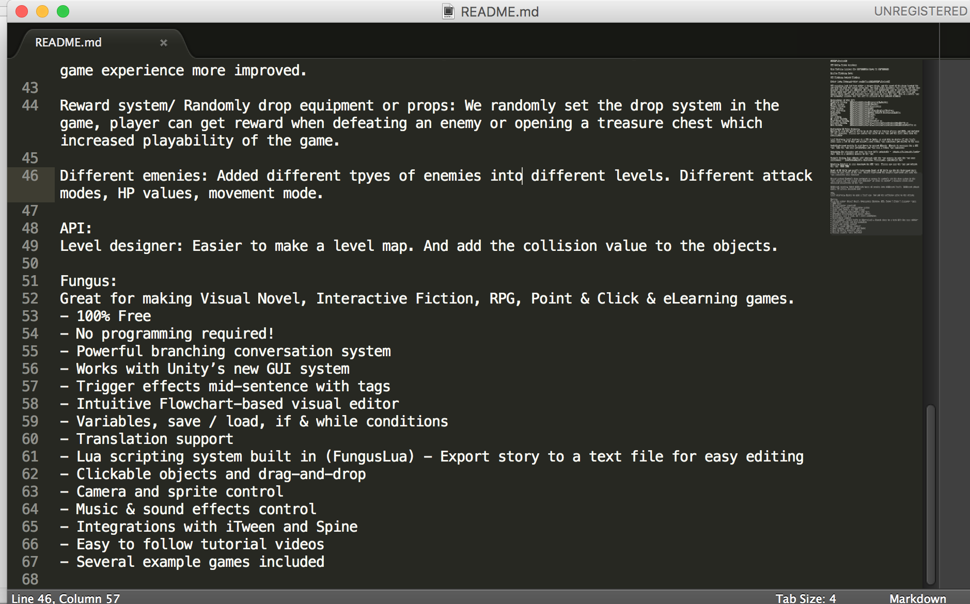

*Readme file include:*

* *Team member names*
* *APP title*
* *APP platform*
* *APP overview*
* *Develop Platform*
* *Instructions of this file*
* *Link to GitHub*
* *All major features explanation*
* *API explanation/ Functions…*

**Publishing**

*(Pass/ Credit/ Distinction/ HD)*

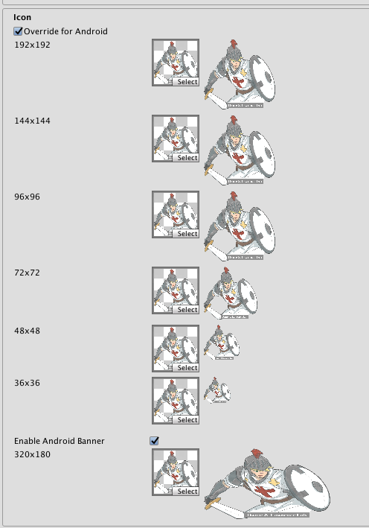 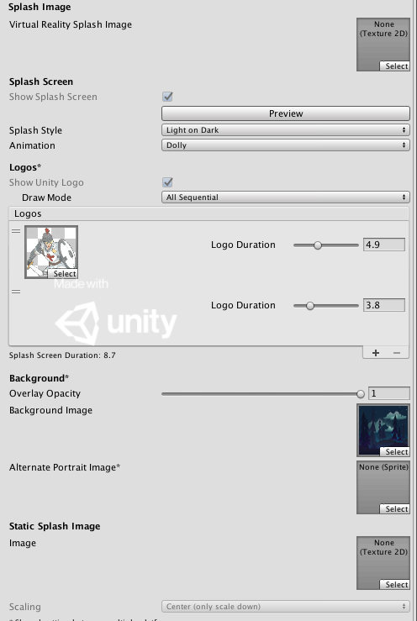

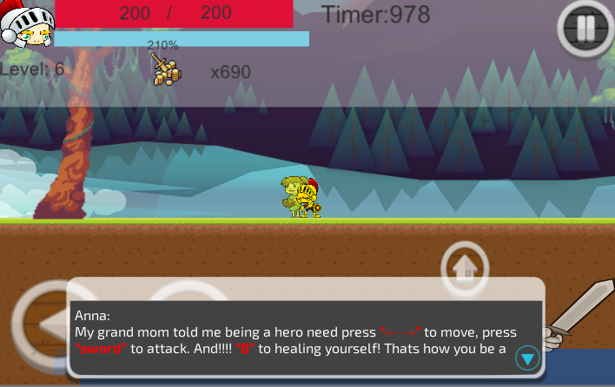

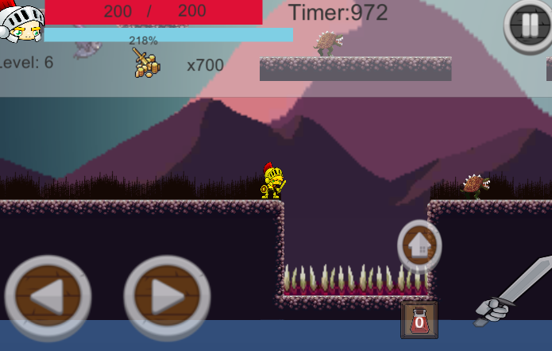

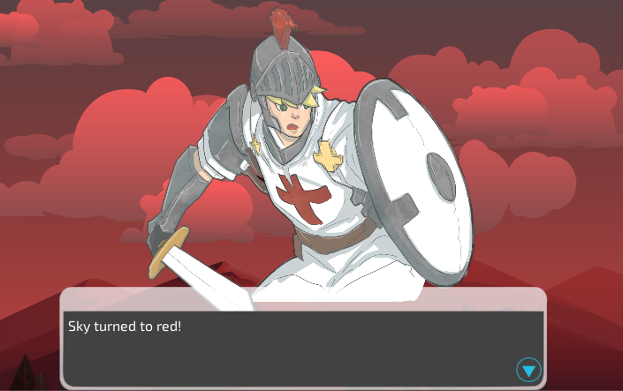

* *Our APP meets all APP store Guidelines.*
* *Has all size icon and splash screens appropriate for the devices.*
* *Has company LOGO and detail.*
* *Had a folder of all information required to publish the APP.*

**Demonstration Video**

*(Pass/ Credit/ Distinction/ HD)*

* Video is clear and audio is easy to understand.
* Have demonstrate all main features working in the APP.